Domain MX Lookup

Open Command Prompt:
Click on Start, Type in CMD

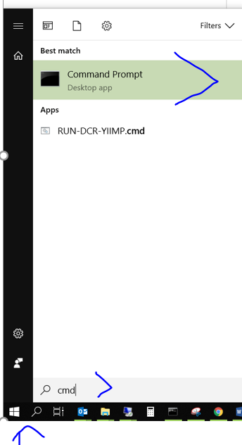

In the Command Prompt Window, type: nslookup (Enter)
Next line, type: set q=mx (Enter)
Next line, type the domain name (enter) – in this example: sautech.net
The Mail Exchanger will show you the where the incoming mail will go to:

